**Linear Algebra and Its Applications 3rd Edition**

### ——David C.Lay

Matrix：填满数字的表格

Preface：

此书由浅入深，登堂入室，于是难免定理累赘，不够深入计算机图形层面。

（本书中指的向量的起点都是原点）

**个人想法：**

对xi的操作 (操作对象) （操作后的结果）

**[] · [] = []**

行数限制最大维度，列向量确定实际维度

**Systems of Linear Equations**

Definition:

多个 形如 A1 **x1**+ A2**x**2 + … + An**xn** = **b** 的集合

Fundamental Problem:Existence and Uniqueness

解的情况:

Inconsistent -> 1、无解， n = 0

/ 2、唯一解，n = 1

Consistent \ 3、无数解，n >= 2

Matrix Notation:

对于A**x = b，**系数矩阵coefficient matrix [A]

增广矩阵augmented matrix [A **b**]

Elementary Row Operations

1.Replacement,（倍加）把某一行换成它本身与另一行倍数的和

2.Interchange，（换行）把两行交换

3.Scaling，（数乘）某行的所有元素乘于非零常数

基本概念：

阶梯型，简化阶梯型，先导元素，主元位置，主元列,主元，自由变量，基本变量

Theorem 1：

Each matrix is row equivalent to one and only one reduced echelon matrix.

行化简算法Row Reduction Algorithm：

Forward phase, backward phase

结果：显式的通解

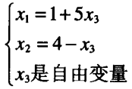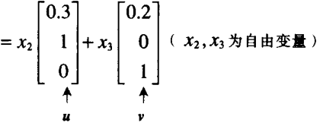

解集的参数向量表示【我们约定用自由变量作参数】

Theorem 2：

线性方程组相容 <=> 增广矩阵最右列不是主元列

若方程组相容，则 (i)自由变量数 = 0，唯一解

(ii)自由变量数 > 0, 无穷多解

列向量：仅含一列的矩阵，简称向量。

(注：（a, b）和 [] 只是不同的表示方法)

若向量相等，则各分量相等

线性组合：



**y**是**v1,…,vn**以c**1,…,**c**p** 为权的线性组合

Span{**v1,…,vn**}：

表示**v1,…,vn**的所有线性组合，称为**v1,…,vn**生成的Rn的子集

*Theorem 3:*

Let A be an m x n matrix, then the following statements are logically equivalent.

1. For each **b** in, A**x = b** has a solution
2. Each b in Rm is a linear combination of the columns ofA
3. The columns of A span Rm
4. A has a pivot position in every row.

Homogeneous Linear Systems齐次线性方程组：

A**x** = **0**

trival solution零解（平凡解）

非齐次线性方程组：

解集 = 特解 + 对应的线性方程组的任意一个通解

Linear independence:

has the only trival solution



反之，则是线性相关（linear dependence）

Theorem 4:

Any set {**v1**,…,**vp**} in Rn is linearly independent if p>n

Theorem 5:

If a set contains the zero vector, then the set is linearly dependent.

T: Rm->Rn, 则Rn为余定义域(domain)

所有T(**v**)的集合为值域(range)

Matrix Transformation:

对基底进行变换，就对整个图形变换。

Linear transformation:

1. cT(**u**) = T(c**u**)标量乘法
2. T(**u** + **v**) = T(**u**) + T(**v**)加法

Superposition principle:(叠加原理)

T(c1**v**1 + … + cp**v**p) = c1T(**v**1) + … + cpT(**v**p)

Rotation Transformation:

[] 旋转 α

单射：余定义域中的像只有一个原像与之对应，

即A**x** = **b** 仅有一个解，即A**x** = **0** 只有平凡解

满射：余定义域中每个元素都是像（余定义域=值域）

**Matrix Algebra**

对角矩阵：除对角线元素外全零

A+B，对应位置的元素相加

rA,每个元素乘以r

AB = A[**b1 b2** …… **bn**] = [A**b1** A**b2** …… A**bn**]

**Determinant(square matrix)**

Definition(略)

Cofactor expansion 余因子展开式 Cij=(-1)i+jdet Aij

Theorem 1：

If A is a triangular matrix, then det A is the product of the entries on the main diagonal of A.

三角形矩阵的行列式为主对角线元素之积

Theorem 2: Row operation

Let A |-> B

1. Replacement, detB = detA
2. Interchange, detB = -detA

3. Scaling. detB = k·detA

Theorem 3:

A is invertible, iff det A ≠ 0

Theorem 4：

det AT = det A

Theorem 5:

det(AB) = detA·detB

Theorem 6:

设

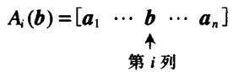

则 xi = det Ai(**b**) / det A

Theorem 7:

其中 Cij为余因子式

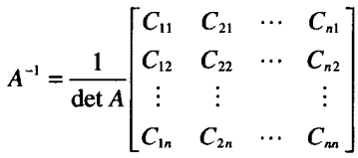

Theorem 8:

若A为2阶方阵，则|detA|为A中的列确定的平行四边形的面积

若A为3阶方阵，则|detA|为A中的列确定的平行六面体的体积

Theorem 9：

令 T: R2->R2是由2阶方阵确定的线性变换，则

T{area of T(S)} = |detA|·{area of S}

同理，三阶方阵确定的T: R3->R3

**Vector Space**

*Definition :*

A nonempty set V of vectors, on which are defined two operations—addtion and multiplication by scalars, satisfy closed.

非空向量集V满足加法和数乘封闭。

*Subspace :*

1. The zero vector of V in H.
2. H is closed under addition
3. H is closed under multiplication by scalars.

若H是V的子空间， 则 ①H是向量空间

②dim H <= dim V

Exception: {} zero subspace

Theorem: V中任意向量的组合，可张成V的子空间H

*Column Space :*

If A = [**a**1…**a**n], then ColA = Span{ **a**1…**a**n}

*Null Space:*

NulA = { :n & A=}

*Integration Theorem:*

1. The null space of an m*n matrix A is a subspace of Rn

The column space of m*n matrix A is a subspace of Rm

1. dim NulA = free variables

dim ColA = pivot columns

1. (Rank Theorem)A is m*n matrix, then

rankA + dim NulA = n (dim ColA = rank A, kernel == null space)

***Imply ->***

dim NulA```free variable```linear dependence

dim ColA ```pivot column```linear independence

*Comment：*Elementary row operations don’t affect the linear dependence relations among the columns of the matrix.

*Basis : ~Column Space*

A spanning set as small as possible

A linearly independent set as large as possible.

尽可能小的生成集，尽可能大的线性无关集。

*Coordinate Map:*

Every in V can be represented uniquely with a basis.One-to-one linear transformation,in other words, isomorphism(同构）

行等价即行空间相同，阶梯型矩阵的非零行形成行空间的一组基。

*Change of Basis:*

P = [ [**b1**]…[**b1**] ]

C<-B c c

用新坐标系的基来表示原基，其权重为新坐标

Algorithm(同步求解):

[**c1…cn** | **b1…bn**] ~ [**I** | PC<-B]

*Application -> Markov Chain*

**Eigenvalues and Eigenvectors (square matrix)**

尽管 -> A可能往各个方向移动，但通常会有些特殊向量，A对这些向量的作用是简单的。

*Definition :*

# An eigenvector of an n*n matrix A is a *nonzero* vector such A=λ for some scalar λ, which is called an eigenvalue,

# respectively , corresponding to

# A=λ存在非平凡解，特征向量所张成的空间为特征空间

# *Theorem 1 :*

# All the eigenvalues of a triangular matrix are the entries on its main diagonal.

# 三角矩阵的特征值在主对角线上

# *Theorem 2 :*

# If v1…vn areeigenvectors that correspond to distinct eigenvalues λ1…λn of an n*n matrix A, then the set { v1…vn } is linear independence.

# 不同特征值对应的特征空间不同

# *IMT(Continued):*

# A is invertible iff its eigenvalue don’t include zero

# *The Characteristic Equation :*

# det(A-λI) = 0

# <=> λ is an eigenvalue of an n*n matrix A

# *Algebraic Multiplicity:*

# Its multiplicity as a root of the characteristic equation.

# *Similarity :*

# If A = PBP-1, then A and B is similar.

# Changing A into B is called a similarity transformation.

# *Theorem 3 :*

# If n*n matrices A and B are similar, then they have the same eigenvalues(with the same multiplicities)

# A和B相似，则特征值相同（重数相同）

# *Theorem 4: The diagonalization Theorem*

# If n*n matrix A is diagonalizable, iff A has n linearly independent eigenvectors.(All is *eigenvector basis*) In this case, the diagonal entries of D are eigenvalues of A that correspond respectively, to the eigenvectors in P.P must be invertible.

# 对角化： A 存在n个线性无关的特征向量，构成特征向量基

# 目标A = PDP-1,

# D是对角矩阵，且主对角线元素是A的特征值

# P中各列是D中各列特征值对应的特征向量，并检验是否线性无关

# 验证AP ?= DP

# *Theorem 5: （Combine 2 and 4）*

# An n*n matrix with n distinct eigenvalues is diagonalizable.

# 含有n个不同特征值的n阶方阵，必可对角化

# *Theorem 6: Diagonal Matrix Representation*

# Suppose A = PDP-1, where D is a diagonal n*n matrix. If βis the basis for Rn formed from the columns of P,then D is the β-matrix.

# Orthogonality and Least Squares

# Definition：

# u·v = uTv

# （定义）If u·v = 0,then u,v are orthogonal

# Theorem 1:

# (Row A)⊥ =Nul A

# 正交集：互相正交的向量集

# Theorem 2：

# Let {u1, …, up} be an orthogonal basis for a subspace W of Rn.For each y in W,

# y = c1u1 + … + cpup , where ci

# Orthogonal Projection: +()



# y 在 W 中的投影 projL y

# projL y = c1u1 + … + cpup, where ci

# Theorem 3:

# Orthonormal set U iff(等价) UT·U = I

# Property: |Ux| = |x|

# 当方阵A是标准正交集，则AT = A-1

# The Best Approximation Theorem:

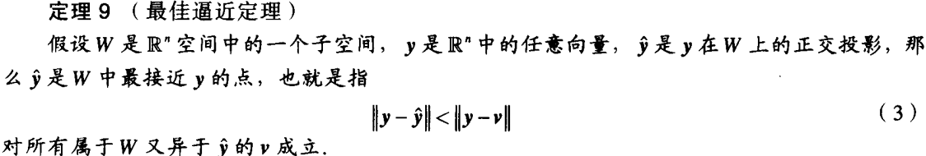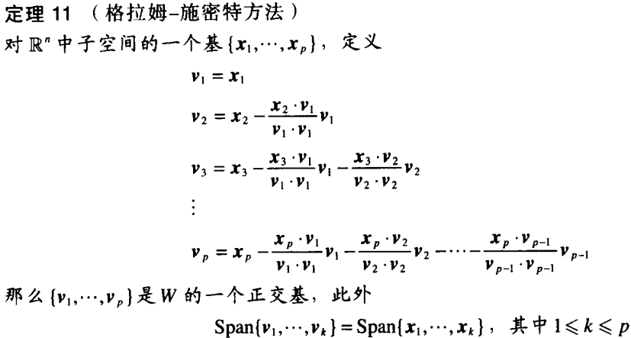

# Theorem 5: QR Factorization(因式分解)

